1. Download GeoSense for windows at <http://geosenseforwindows.com/index.html>
2. Install the Software for GeoSense.
3. After Installation Go to control panel -> Hardware and sound -> Location and other sensors

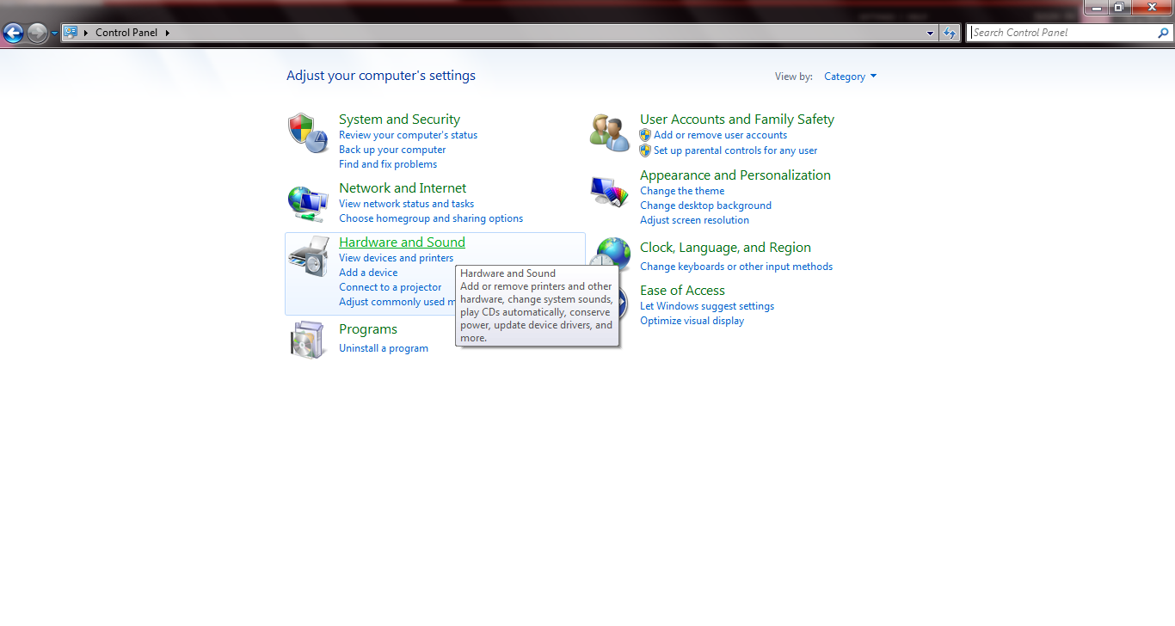

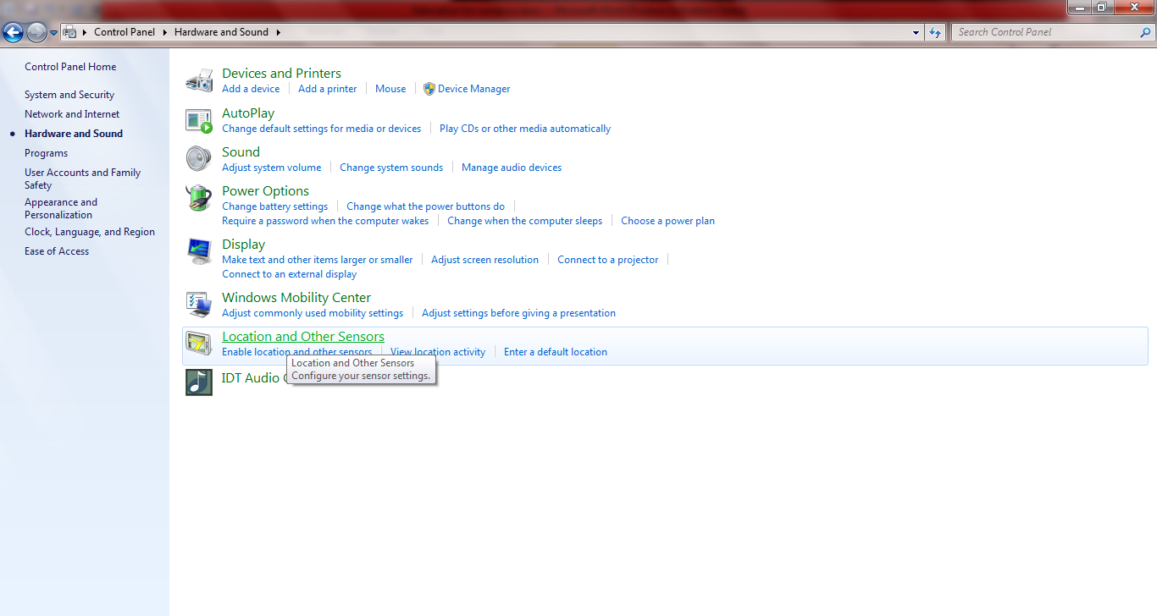

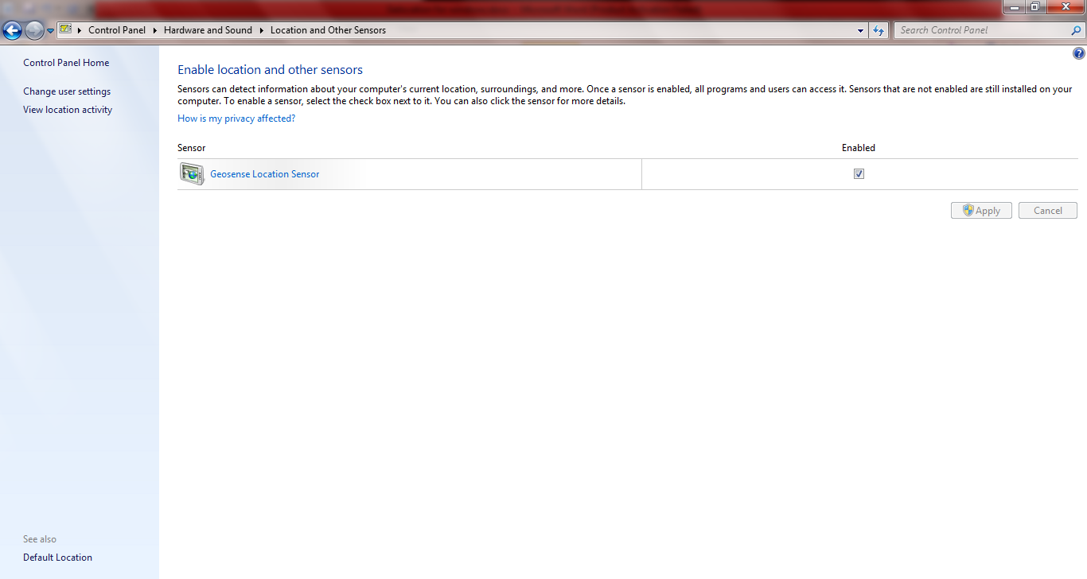

Make sure the checkbox is enabled

1. Using “using System.Device.Location” we can access the geo location of the system.

Sample code:

/**

* The GeoCoordinator watcher to get geolocation data

*/

GeoCoordinateWatcher LocationWatcher = new GeoCoordinateWatcher(GeoPositionAccuracy.High);

//try to start geo watcher and wait for 5 secs to start

LocationWatcher.TryStart(false, TimeSpan.FromMilliseconds(5000));

//attach a event listener for change of position

this.LocationWatcher.PositionChanged += new System.EventHandler<GeoPositionChangedEventArgs<GeoCoordinate>>(this.Location_Changed);

/**

* Event to listen for the geo location change

*/

private void Location_Changed(object sender, GeoPositionChangedEventArgs<GeoCoordinate> e)

{

if( e != null && e.Position != null)

{

//get the location coord

var coord = e.Position.Location;

m_gps_count++;

m_position = ":" + m_gps_count.ToString() + ":N:" + coord.Latitude + ":W:" + coord.Longitude+":";

}

}